Concept Document – Gravity Run

Melvin Magro, Naomi Zammit Ciantar, Maria Grech and Paul Falzon

**General Idea**

The main idea was to present a game which is easy to play and understand, but at the same time offers a sense of challenge to the players. We wanted our 2D game to have a good flow in it and grab the players’ attention and focus as much as possible. Our inspiration games where: *Super Mario, Jetpack Joyride, Adventure Runner, Subway Surfer and Flappy Bird*. We tried to combine these mobile addicting games into one game that can be played for a long time.

**Psychological Concept of Play**

Our main psychological aspect of the game is flow and we tried giving a good state of flow by making the game challenging, simple, give immediate feedback to the players and engaging. By giving the player less buttons to learn the game and leaving the story short, the player will get into playing the game much faster without making it a bore in having to read a lot of text. Throughout the progress of the game, every 10 drops collected, the screen decreases in width and on every 9th colour drop, the visibility of the screen would become harder to see, but will return to normal on the 10th. This way the game becomes more challenging by time to maintain flow, since players would need a faster reaction time and black drops would seem more unpredictable.

**Rules**

* Players need to pick colour drops to score points
* Players cannot hit the black drops, or he will lose
* Players must use the space button to switch gravity

**Mechanics**

* Pressing space will switch gravity (either up or down)
* Picking drops will colour the background and score points

**Iteration Description**

The game will start with the back story and the instructions of the game and when the next button is clicked four times the game starts. Black drops and colour drops will be in your character’s way and you need to evade black drops and pick up colour drops. By changing the gravity using space bar, one can play around black drops to avoid them and pick up the colour drops to advance and gain points. When hitting a black drop the game will end. When hitting coloured drops, the score will increment by 1 and every 10 colour drops collected the game will have its screen width size reduced which makes the game harder.

**Sketches**

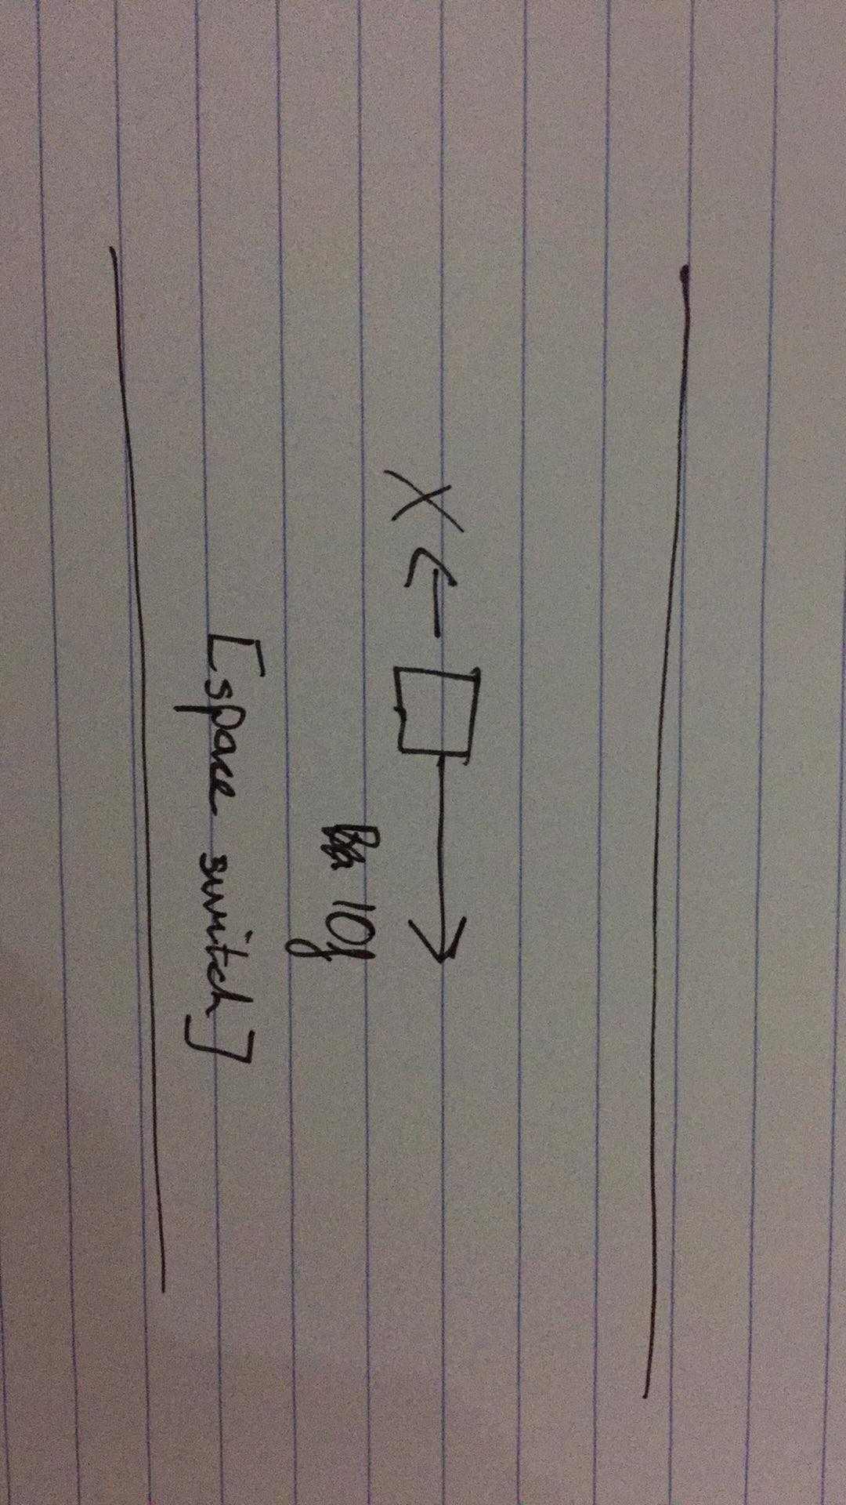

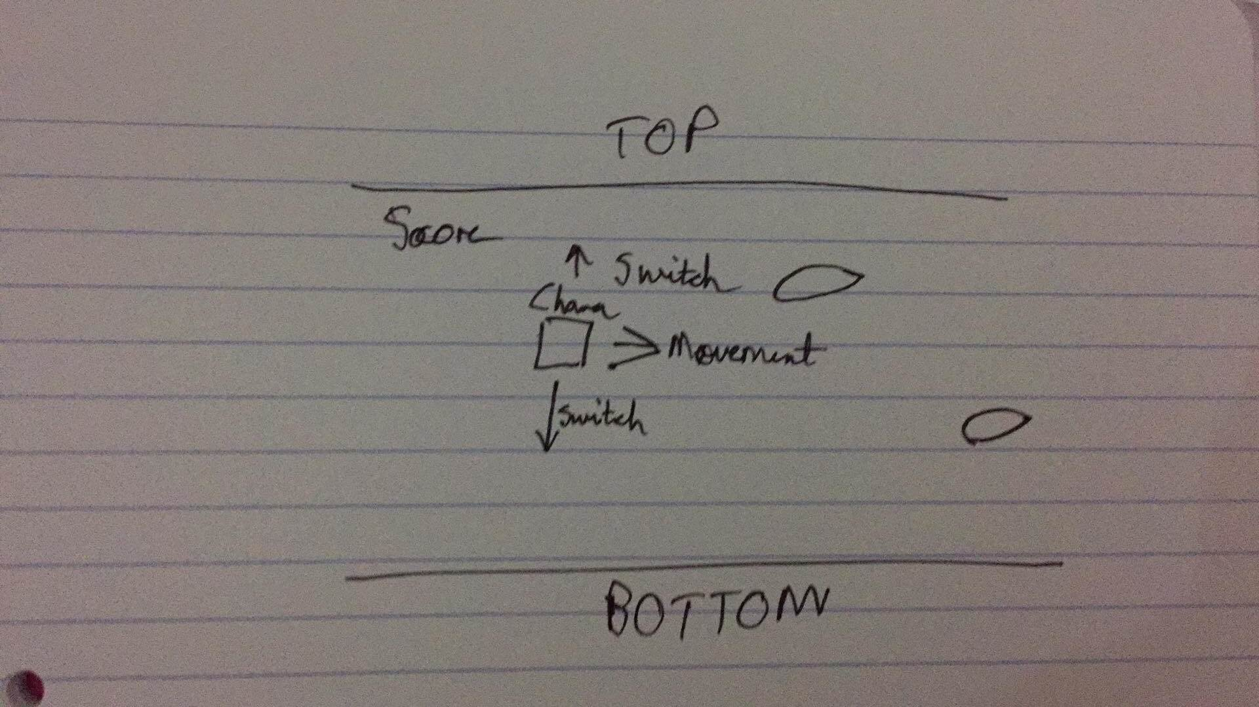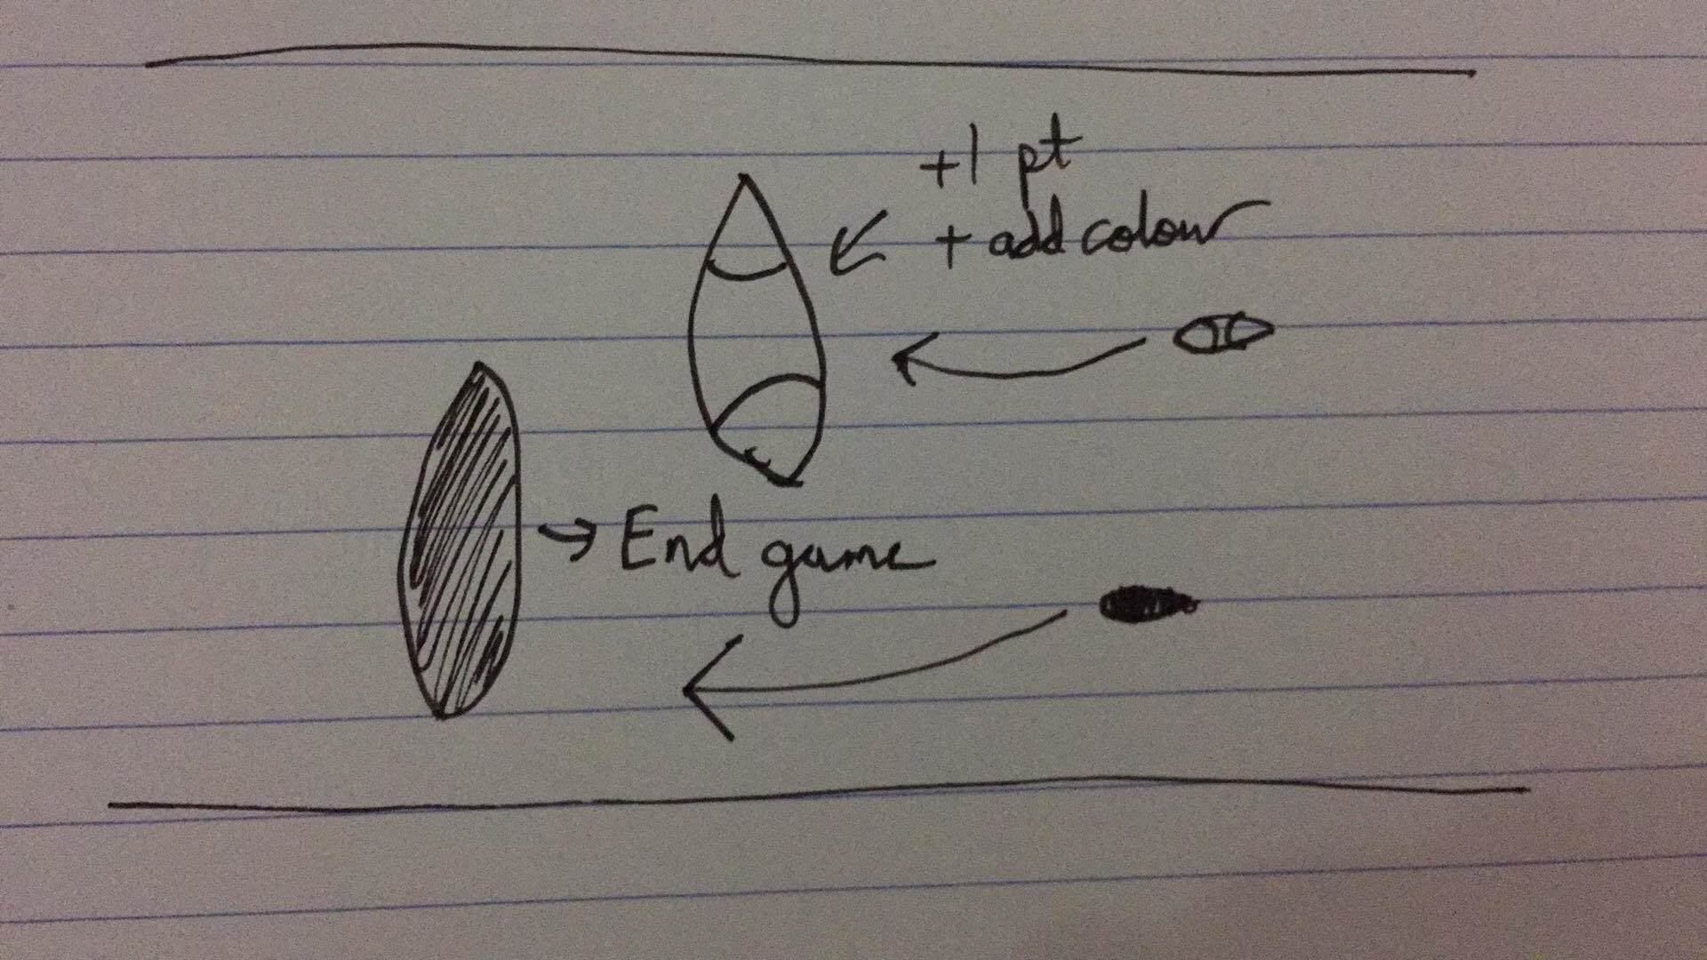

**Renders**

Storyline Screen 1

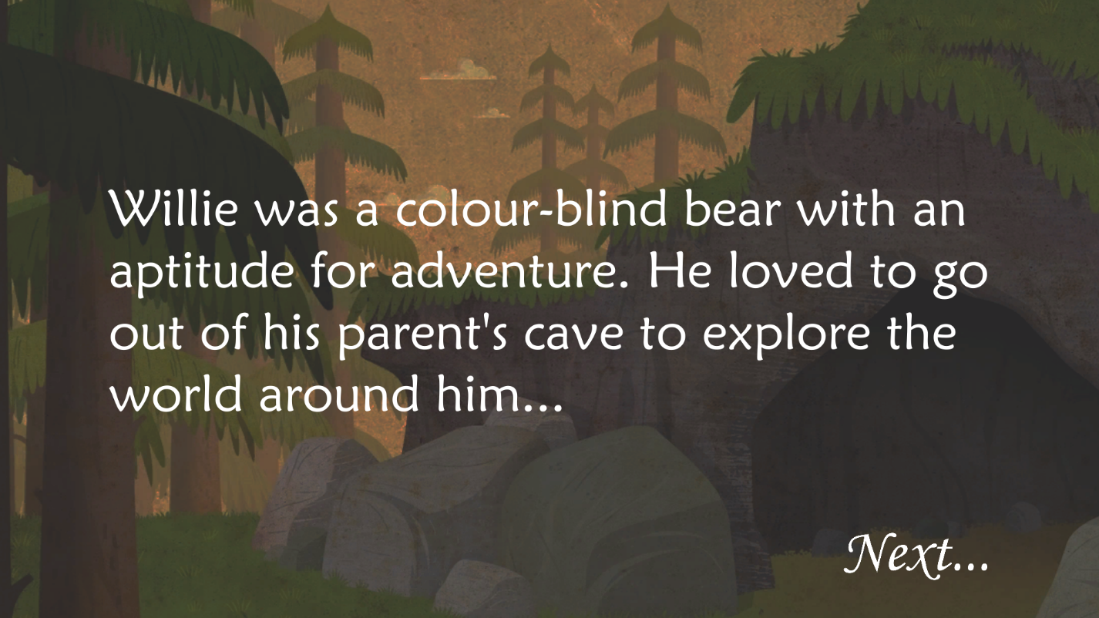

Storyline Screen 2

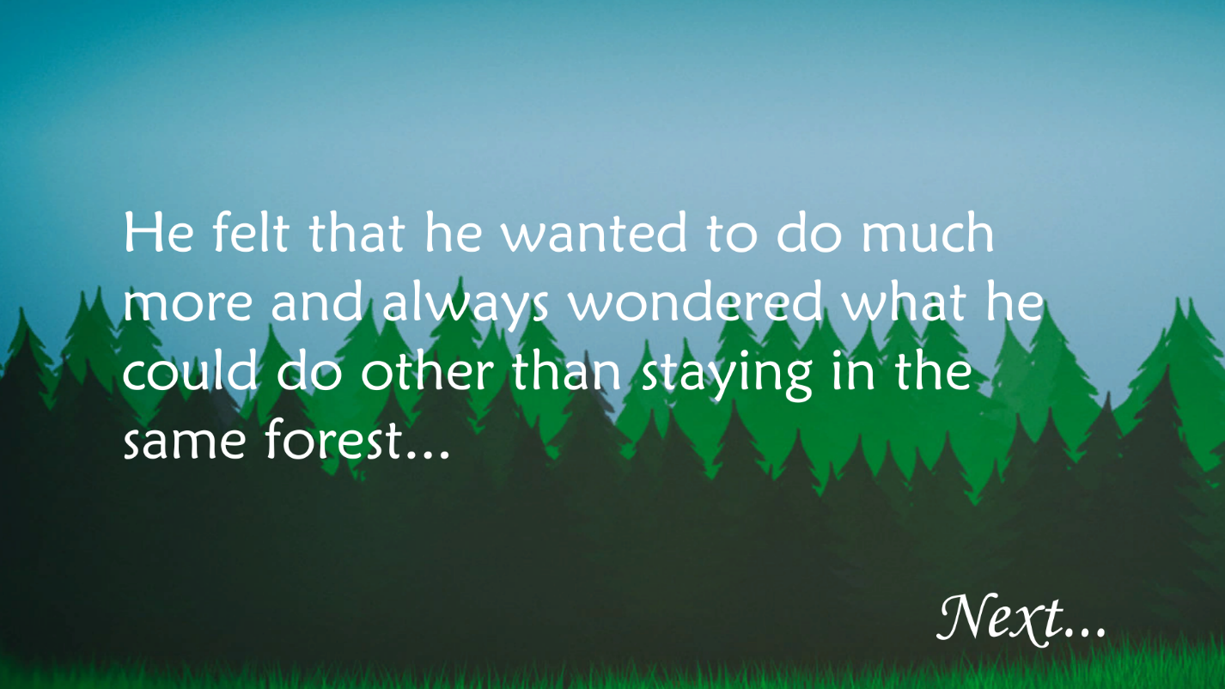

Storyline Screen 3

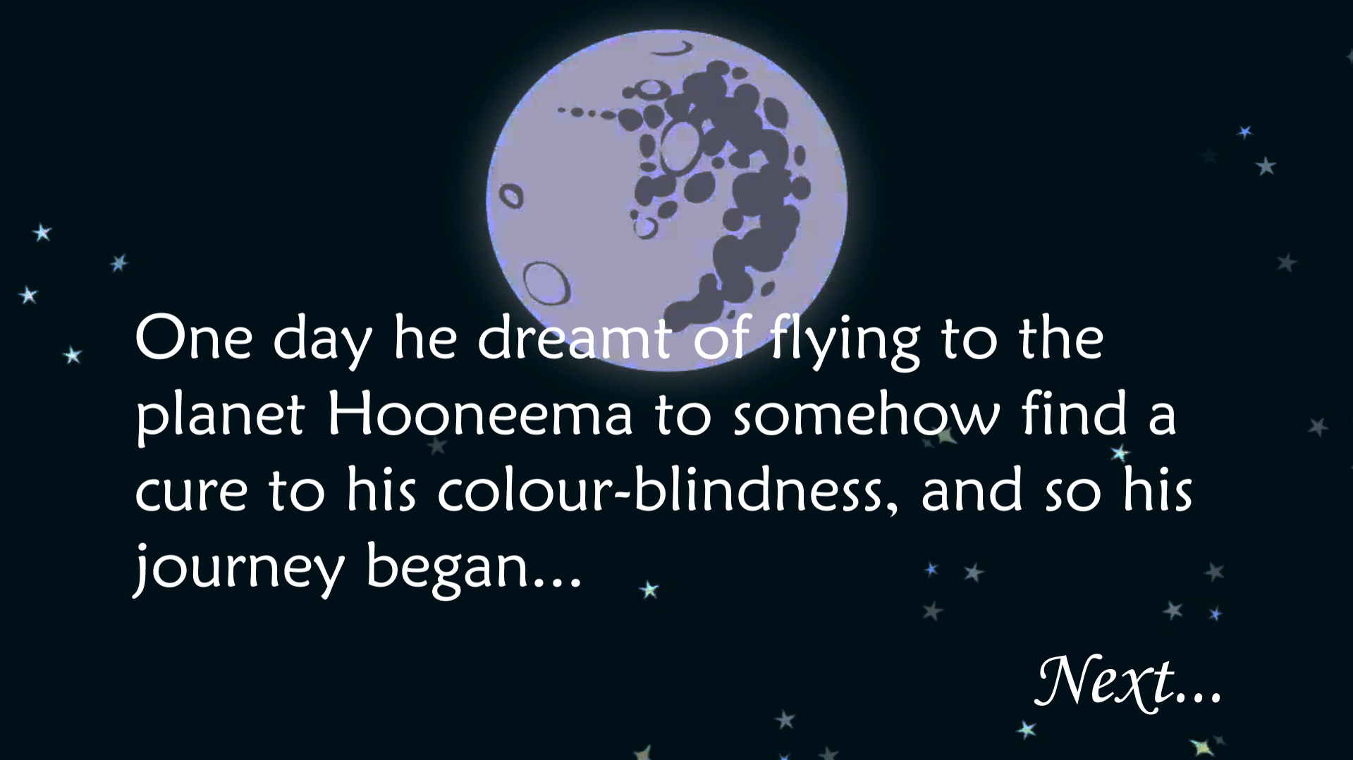

Instructions Screen

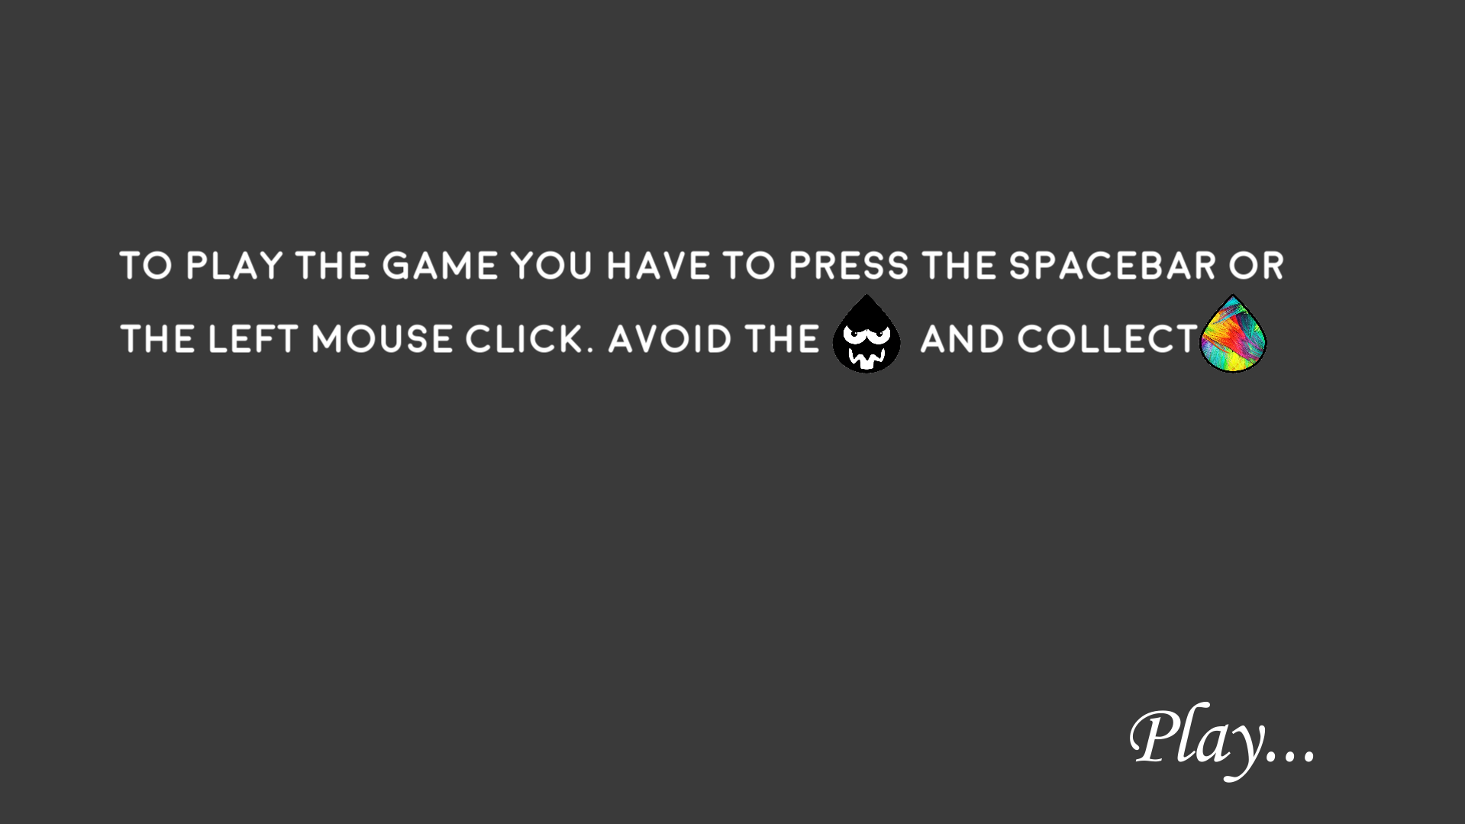

Start of the Game

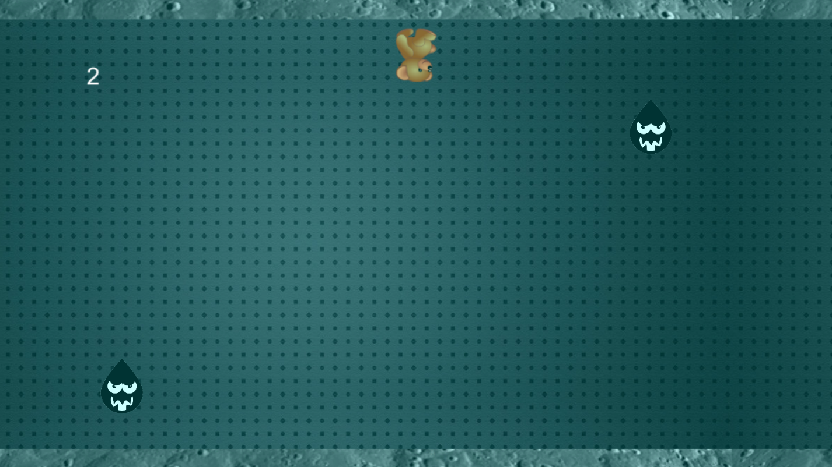

After 20 points, width of screen is reduced

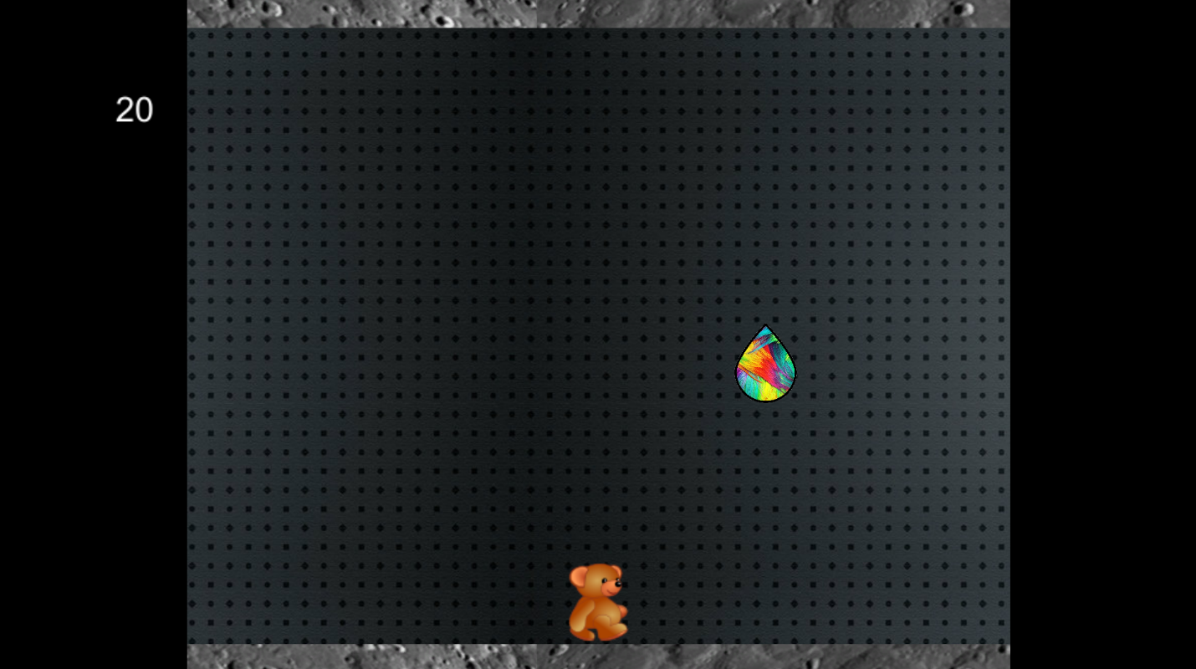

Game Over Screen

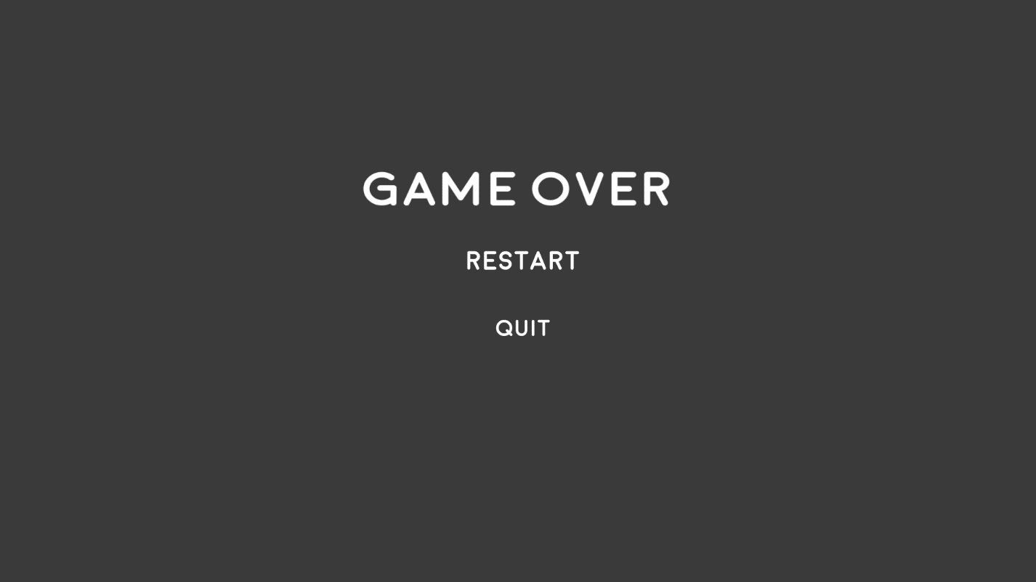

**Playtesting**

I had one of my peers (Enrico) test out the game to get feedback on the game and before the game even started, I noticed how Enrico was confused as to how the game should be played. Me and my team did not even think about including instructions for the game which was something pivotal that we had overlooked. We later added an instruction game screen on how to play the game. On the bright side, I noticed that when Enrico was playing the game, he became focused in it and found himself being frustrated whenever he hit the black drops, which in turn made it a challenge against himself to do better in the next game. I was happy to see this, since it was one of the ingredients to achieving flow in games.

I conducted another playtest after the game was fully completed on another student that didn’t play a lot of games. During gameplay, she told me that she didn’t like the colour changes that much since it made it difficult for her to see the screen (this was one of the goals). She immediately understood how to play the game even though she had little experience with them. As the game progressed I asked her what she was noticing, and she mentioned the colour changes only and when she managed to reach a score of fourty, I asked her the same question again and told me that she wasn’t sure, but it seemed as if the bear was running faster. She was totally unaware of the screen width being reduced in size! When I mentioned this to her, she was surprised how she didn’t notice it before.

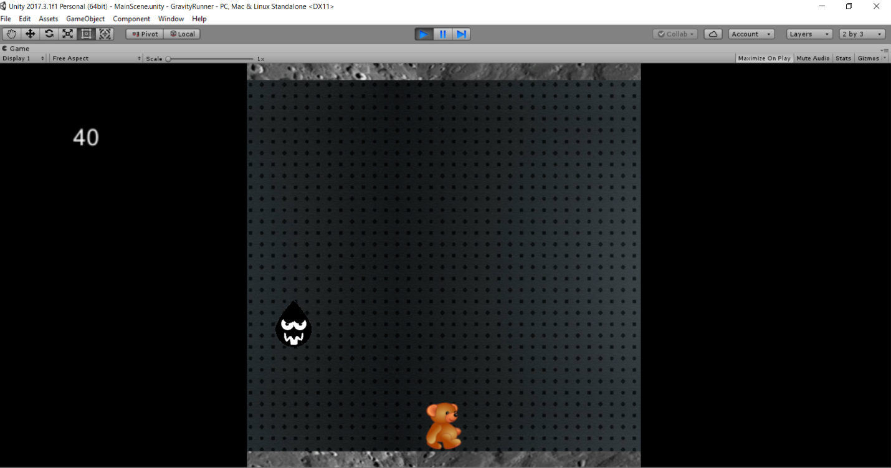

The width of screen is reduced drastically at a score of 40

After discussing this with her and asking her how it was possible that she didn’t notice the screen size reduction, she showed me a very interesting video, which then made me understand. In this case, the game managed to grab her focus, but lack of resources, collectibles and the colour change didn’t make the game too appealing for her. The rate was 6.5/10.

<https://www.youtube.com/watch?v=Ahg6qcgoay4> *-> The video she showed me which made me understand how she didn’t notice the screen size changing.*